Lab 1 Robot Programming I: UR3

Name of Student: Weijie Liang

NetID: weijiel4 3200112393

Lab Partner: Qianqi Liu

1. **Introduction**

In this lab, we need to move a "tower" of three blocks using robot arm, from one of three locations on the table to another one based on the rules of "Towers of Hanoi". The Tower of Hanoi is a mathematical puzzle that consists of three rods and several disks of different sizes which can slide onto any rod. The puzzle starts with the disks in a neat stack in ascending order of size on one rod, the smallest at the top, thus making a conical shape. The objective of the puzzle is to move the entire stack to another rod, obeying the following simple rules: 1) only one disk can be moved at a time; 2) each move consists of taking the upper disk from one of the stacks and placing it on top of another stack; and 3) no disk may be placed on top of a smaller disk. The setup of lab 1 is shown in the figure below.

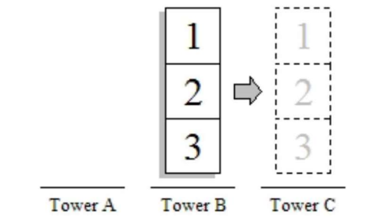

Figure 1

1. **Method**

At the begin, we have blocks 1,2,3 at Tower A and we need to move them to Tower C. We first figure out how to move blocks from A to C theoretically. The steps are (1->C), (2->B), (1->B), (3->C), (1->A), (2->C), (1->C). Then we implement each step one by one on the graphical user interface of UR3. In each step, we first raise the arm, move horizontally in right or left direction, move down, suck and wait for some time, raise the arm, move horizontally in right or left direction, move down towards the destination and turn off the sucking function. Also, we didn't forget to hult the mechine after we finished the task. We have implented our methods for several times. At the beginning, we just want the arm to directly move from the starting point to destination. However, we found that the arm may collide other blocks. Consequently, every time we want to move the arm, we need to raise it up first so that it will have enough space to move.

1. **Data, Results and Conclusion**

In wrapping up the lab, we gleaned valuable lessons about the UR3 robot, especially in executing tasks that demand precision and thoughtfulness. To maintain orderly block stacks during the Tower of Hanoi exercise, precise control over the robot's movements was essential. This involved not just programming the sequence of moves accurately but also fine-tuning the robot's grip and release functions to ensure each block was placed precisely, avoiding any misalignment or instability.

The exploration of MoveJ, MoveL, and MoveP commands revealed their distinct functionalities and optimal applications. MoveJ was instrumental in repositioning the robot arm efficiently between distant points, leveraging the robot's joint movements. This was particularly useful for broad movements but less so for tasks requiring strict path adherence. Conversely, MoveL became the go-to for tasks demanding high precision, as it guarantees a straight-line trajectory, ensuring the end effector's orientation remains constant—critical for stacking blocks neatly. MoveP, with its constant speed capability, was adept at performing smooth circular and intricate movements, offering a blend of precision and fluidity necessary for encircling the block positions without disrupting the setup.

This lab not only deepened our understanding of the UR3's capabilities but also highlighted the strategic importance of choosing the appropriate movement commands based on the task's specific needs. The hands-on experience emphasized the nuanced approach required in robotic programming to achieve tasks efficiently and with high precision, showcasing the potential of robotics in executing complex tasks with remarkable accuracy and control.